**Home**

* IGF Logo clickable to Home tab
* Welcome to International Gourmet Foods Block
  + International Gourmet Foods is the leading wholesale distributor of gourmet specialty products, providing high quality, innovative items from around the world. We listen to our customers daily and our commitment to you will always be our top priority. IGF will always bring you superior service, quality products and competitive prices.
    - Add a “Learn More” button that links to “About Us”
* Picture Slideshow Block
  + Seasonal Items Info – Contact Sales Representation
  + Sign up for IGF Monthly Newsletter Info – Link to Contact Us
  + Weekly New Items Info – Contact Sales Representative

**About Us**

* How it all Started [WORKING ON]
  + International Gourmet Foods, Inc. (IGF) was founded by Maurizio Di Benigno in 1987. A life-long passion for quality products, fine tasting foods, and a wealth of experience in the food service industry, inspired the principles on which Maurizio has built this company. His commitment to the needs and desires of his clients and his determination to source products of quality and value built the reputation of IGF as one of the premier gourmet food import and distribution companies in the industry.  
    The initial product list of four items: sundried tomatoes, extra virgin olive oil, saffron and pasta, was modest, particularly in comparison to the current day list which now boasts more than 5000 products, from all around the world. In expanding our product list, we seek out new and innovative goods, which will excite and inspire our customers.
* Who We Are [WORKING ON]
  + Quality, Service and Value are the hallmarks of International Gourmet Foods, Inc. (IGF). From its modest beginning, IGF was and still is a family owned and operated business that was founded on solid values and principles that we continue to grow and develop. We keep our core mission to seek out innovative, superior quality products from around the world and deliver these to our customers, quickly, easily and at the right price. Our focus and commitment to these principles is inevitable.
* Our Mission [WORKING ON]
  + From its original inception, the mission of IGF has been simple; keep superior customer service at the heart of our business. The initial concept was to import a small number of high quality items in large quantities. This facilitated competitive prices and enabled us to offer a low delivery minimum – both cornerstones of good customer service.
* Our Specialists
  + **Karen Dee | Cheese Specialist**  
    Karen Dee has been with IGF for more than 8 years and in the food service world for more than 20 years. Karen has developed an encyclopedia on every cheese IGF stocks which is more than 600 cheeses from around the world. Karen is available for special events, tastings, demonstrations, pairings, staff training and consultations.
  + **Giuliana Volpi | Dessert & Coffee Specialist**As both dessert and coffee specialist, Giuliana Volpi assists the IGF Sales Team and their clients with new and existing product training, marketing, brand quality control and on location professional training and demonstration. By maintaining excellent communication with the Illy and Bindi Desserts area brand managers, Giuliana is always one step ahead of the trend!
  + **Patrice de Bortoli | Protein Specialist**Patrice de Bortoli is the leading Charcuterie & Center of the Plate specialist from Maryland to Georgia! With a finger on the pulse of the industry, Patrice sources what chefs are looking for and is always at the ready for a new product presentation, in house demonstrations and staff training. For more than twenty six years, IGF has been providing the finest restaurants, hotels, country clubs, executive dining rooms and retailers with the highest quality meat, game, poultry and cured meats.

**Products [WORKING ON]**

* What started off with just three items and now having over 5000 high quality items, here are the categories of our array of products we carry.
  + Baking and Pastry Supplies
    - We have a wide selection of ingredients that are perfect for your pastry chefs and bakers. Create your delicatessens with the richest ingredients that we have to offer.
  + Bar & Beverage Service
    - Espresso, Syrups, Mixers, Bitters, Water, Juices, and Sodas. We carry a selection of beverage options perfect for your café, restaurant, bar, and even your gourmet retail stores.
  + Beans & Legumes
    - We have a collection of beans that are not only great for hearty meals, but have striking and distinctive marks that compliment your creations.
  + Bread, Tortillas & Wraps
    - We insure the best quality artisan breads, tortillas and wraps. Our selection of par-baked breads are made with the finest ingredients and when they’re ready, they have the perfect crunch with every bite. Try our tortillas and wraps too!
  + Candy, Sweets and Desserts
    - Do you have a big sweet tooth? We carry a full line of prepared desserts, as well as cookies, candies and other sweets to satisfy your sweet tooth.
  + Cheese Corner
    - Artisan & Domestic
      * Our artisanal and domestically produced cheeses are made to perfection and delivered to your doors the way American cheesemakers intended it to be. We have a wide variety of styles, milks, and aged cheeses.
    - Imported
      * From Canada to Argentina, Italy to Spain, here at IGF we carry the finest cheeses from all over the world.
    - Cheese Plate Program
      * A well composed cheese plate should have a base of at least 5 cheeses. Three or four is sufficient but having five cheeses really allows for a variety of different styles, ages, textures and flavor profile.
  + Chips, Crackers and Snacks
    - For every crunch from an opened bag… we have a huge selection of the best quality and healthful snacks that you can choose from to make it an addition to your meal deals or add to your selves.
  + Condiments & Sauces
    - Our condiments and sauces that we carry are one from the best and are great accompaniments for your perfect meal.
  + Dairy Products
    - We carry a selected collection of dairy products.
  + Flours & Grains
    - Stock your pantry with all the grains and flours that you need for you next dish. We offer a range of pizza flours to baking flours and brown rice to other grains.
  + Fruit, Fruit Purees & Preserves
  + Honey & Syrup
  + Hor D’Oeuvres
    - Our hors d’oeuvres are made to please the most discerning palates. We carry an assortment of appetizers that are perfect for catering and banquets.
  + Microgreens *NEW*
  + Mushrooms & Truffles
  + Non-Food & Paper Products
    - It may not be an ingredient to add to your popular dish, however we can offer you with our broad range of packaging, cleaning supplies, bags, utensils, pizza boxes, and anything else non-food and paper product related.
  + Nuts & Seeds
  + Oil, Olive Oil & Shortening
    - We searched the world for your needs of the best oils around the world.
  + Olives
    - Tell your taste buds to pack their passport for a trip to the countryside! That’s how fresh, vibrant, authentic and delicious our IGF fresh olives are!
  + Pasta & Noodles
    - From fresh to dry pastas & noodles, we carry a vast selection of stuffed, local, gluten-free, and specialty cut pastas and noodles.
  + Protein Block
    - Center of the Plate
      * Our Center of the Plate specialties include but are not limited to: American and Australian Wagyu beef, Grass-fed Naked Beef, Carolina Bison, New Zealand lamb, Free-raised Wisconsin veal, Six Point Berkshire pork, Heritage Berkshire pork, Ashley Farms all-natural poultry and game birds, Squab, Texas Bandera Ranch Quail, Cervena Venison, Texas Wild Boar and Antelope, Naked Bird chicken sausages, Chateau Royal game sausages, German sausages and more!
    - Charcuterie & Deli
      * We currently carry over 250 international and domestic artisanal charcuterie items. These are PERFECT for your charcuterie boards!
  + Salt, Herbs & Spices
    - We have a robust selection of salt, herbs and spices from all around the world, that brings that additional special flavor to your dishes.
  + Seafood Specialties
    - Produced straight from the sea, we offer the best of the best seafood specialties from smoked salmon to canned tuna, anchovies and more.
  + Sugar, Specialty Sugar & Substitutes
    - Explore our wonderful world of sugar, specialty sugar and sugar substitutes.
  + Vegetables
    - We carry the high quality of vegetables, including the top of the line canned, IQF, dry, and prepared vegetable products.
  + Vinegar

**Services**

* Overview
  + At International Gourmet Foods, our goal is to provide our customers with the best service in the industry! Here are a few services that set us apart from our competitors:
    - Late ordering deadlines
    - Low order minimums
    - Delivery five days a week by our all-temperature trucks to ensure product is kept at optimal integrity
    - Delivery by courier anywhere in North America
    - We employ a “Cheese Specialist”, “Dessert & Coffee Specialist”, and “Protein Specialist” to provide education for our sales force and our customers. **Click Here for more information about our Specialists (link to Specialist Page)**
    - We provide specialized warehouse tours and personalized tastings! Spend a day with us at any of our three locations
    - Marketing service available. Ask your sales representative for more information
* Who we service
  + International Gourmet Foods services a wide array of customers in the foodservice industry. We serve to restaurants, gourmet markets, clubs, caterers, bakeries, country clubs and hotels throughout our delivery region and via common carrier. We have dedicated ourselves to providing the highest quality food products, with the highest quality service level in the industry. This is why our customers are some of the finest chefs and people in the world and keep coming back to us.
* Where we service
  + We service the Mid-Atlantic and Southeast regions of the U.S with our fleet of all-temperature trucks and via common carrier throughout the country. Please see our specific locations for more information.
    - Virginia, District of Columbia, Maryland and the Eastern Shore, West Virginia, North Carolina, South Carolina, Georgia
  + We also provide shipping service all over the United States, Puerto Rico, Canada and Mexico via UPS, Fed-Ex or Common Carrier.
  + **Keep Map and Hot Spot Animation**
    - Clickable link page to Springfield
      * Springfield, VA  
        Where it all began 26 years ago… A home to our Corporate Office and largest distribution center. IGF Springfield services from Delaware to North Carolina and most places in between. Our office is conveniently located off of I-95 and minutes away from the beltway. We invite you to make an appointment for a private tour of our facilities and/or personalized tastings.  
        ADDRESS//LOCAL #//TOLL FREE#//FAX#  
        Google Map Location Block (Map data) instead of link to another window
    - Clickable link page to Charleston
      * Charleston, South Carolina Division  
        Our Southeast distribution center is located in the heart of the low country and its ever growing culinary reputation, Charleston, South Carolina. This area continues to grow its place in the gastronomic scene in America an International Gourmet Foods is proud to serve this growth! Our staff has been selected right out of some of the best restaurants, bakery and food service businesses in the area and represents over 35 years of experience in the food business. Our delivery areas include all local Charleston areas, Myrtle Beach, Beaufort, Hilton Head, Columbia, Greenville, SC and Savannah, GA.  
        ADDRESS//LOCAL #//TOLL FREE#//FAX#  
        Google Map Location Block (Map data) instead of link to another window
    - Clickable link page to Atlanta
      * Atlanta, Georgia Division  
        Our most southern distribution center is located in Atlanta, Georgia. It is one of our newest distribution centers within International Gourmet Foods. We are proud to continue to support the growth in the foodservice industry in the Atlanta area. Chefs from all over the area also have the opportunity to visit our warehouse for a tour and meet with our sales representatives. Our warehouse is located close to all major highways & Hartsfield-Jackson International Airport. Our delivery areas include all local Atlanta areas, Macon, Athens and Chattanooga, Tennessee.  
        ADDRESS//LOCAL #//TOLL FREE#//FAX#  
        Google Map Location Block (Map data) instead of link to another window

**Events**

* Check Back Soon. – We are always excited to announce when our upcoming Food Shows will be. Check back here with more details regularly.

**Contact Us**

* Locations Block
  + International Gourmet Foods – Corporate Office//Address//Phone #//Toll Free #//Fax #//Office Hours
  + International Gourmet Foods – Charleston//Address//Phone #//Toll Free #//Fax #//Office Hours
  + International Gourmet Foods – Atlanta//Address//Phone #//Toll Free #//Fax #//Office Hours
* Connect With Us
  + Like us on Facebook
  + Monthly Newsletter Sign-Up
* How to Apply for an Account
  + Please download and complete our New Customer Application and submit back to us by Fax (703) 569-1065 or email with your contact information to [info@igf-inc.com](mailto:info@igf-inc.com). Once submitted, you will be contacted by Customer Service with confirmation.
    - Picture of front cover of new customer application, linkable to download access of application
* Need More Information? Please email: [info@igf-inc.com](mailto:info@igf-inc.com)
* Please note: We are a whole sale distributor and cannot sell to individual customers.

**Careers**

* We are always seeking well qualified Salespeople and Drivers to add to our staff of educated, caring and devoted service providers. We are often hiring in our warehouse as well as in administrative areas.  
  We offer very competitive pay and a well rounded benefits package.  
  If you are interested in employment please submit your resume to: [info@igf-inc.com](mailto:info@igf-inc.com)   
  Attn: Human Resource  
  To download our Employment Application Click Here.

**Design**

* Background/Back Drop
  + White & Green diagonal stripes
* Font & Color Scheme
  + Font: Franklin Gothic Book/Trebuchet MS/Veranda
  + **NO MORE COMIC SANS MS!!**
  + Neutral
* Banner/Tabs
  + Keep
    - Twenty Six Years and Growing
    - IGF Logo – International Gourmet Foods
  + Get rid:
    - “Register for our upcoming food show or click ‘Upcoming Events’ for more info”
    - Middle picture behind Information Blocks
  + Place Tabs directly under the logo and continue
    - Tabs:
      * Home
      * About Us
      * Products
      * Services
      * Events
      * Contact Us
      * Careers

**Example/Current Top Banner:**

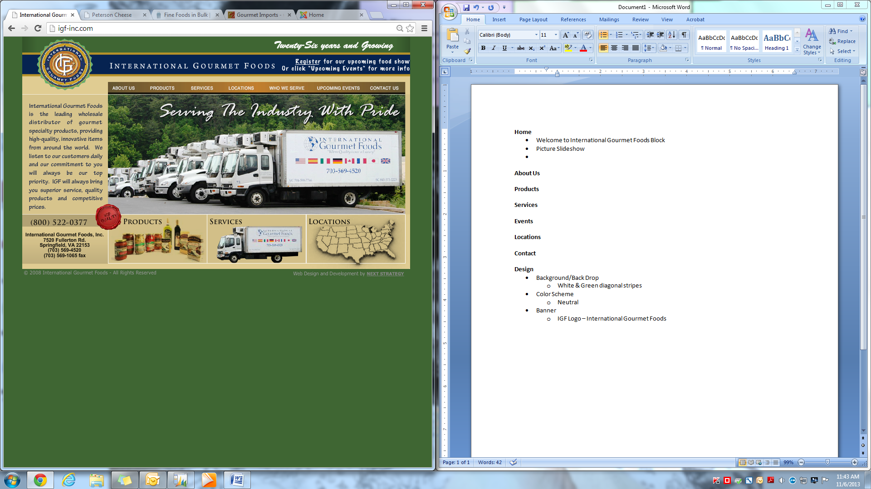

* Bottom Banner/Block
  + 2013 International Gourmet Foods – All Rights Reserved (Left Align)
  + International Gourmet Foods//Address//Phone #//info email (Right Align)

**Example of bottom banner/block:**

